Geochemistry, Geophysics, Geosystems
Supporting Information for
Multi-band Raman analysis of radiation damage in zircon for thermochronology: Partial annealing and mixed signals

Birk Härtel, Raymond Jonckheere, and Lothar Ratschbacher
Geologie, TU Bergakademie Freiberg, 09599 Freiberg, Germany

Contents of this File
Text S1, S2, and S3
Figures S1, S2, S3, and S4

Additional Supporting Information (Files uploaded separately)

Tables T1 and T2

Introduction

This supporting information gives an overview about the samples from Myanmar; details of the pressure-temperature-time data will be published elsewhere. Texts S1 and S2 describe samples M71, K86, and K92, and derive temperature-time paths. Text S2 also describes sample K91, sampled near the locations of K86 and K92, in the Katha range of Myanmar, expected to have experienced a similar metamorphic overprint and temperature-time path. Text S3 discusses the forward modeling approach used to calculate the D₂/D_{ER}-D_{ER} trends shown in Figure 5 of the main text. Tables S1 and S2 list the zircon Raman data investigated in this study.

Text S1. NE Mogok belt, sample M71 (5371)

Location: 24°14.125’ N, 97°23.401’ E, 178 m.
Petrology: Clinopyroxene-amphibole granite with aplite. Clinopyroxene, often mantled by amphibole, is diopside. Green amphibole is mostly hastingsite/magnesio-hastingsite. Granular plagioclase displays normal zoning. Porphyritic, cm-sized orthoclase shows perthitic unmixing and microcline twinning at its rims. Accessory minerals are biotite, ilmenite, zircon, and apatite. Ti-in-amphibole thermometry and Al-in-amphibole barometry gave pressure-temperature (P-T) conditions of 788 (±50) °C/0.43 (±0.06) GPa; these estimates model the magmatic crystallization of the amphibole core.
Geo-Thermochronology: (a) Aplite. Zircon (U-Th)/He (ZHe) age is 15.8 ± 1.9 Ma (n = 2, 2s). Apatite fission track (AFT) age is 13.4 ± 2.0 Ma (2s). (b) Granite. SHRIMP U-Pb zircon youngest spot age is 36.8 ± 2.0 Ma (2s), which is interpreted to date crystallization; spot-age range from 64.0 to 50.3 is inheritance. AFT age is 13.5 ± 1.0 Ma (2s). Apatite (U-Th)/He (AHe) age is 11.1 ± 0.9 Ma (n = 2, 2s).
Temperature-time (T-t) path: The granite crystallization temperature and its uncertainty are interpreted as the zircon crystallization temperature. In a first step, we determined the sample cooling rate using classic mineral closure temperatures (e.g., Carlson, 2011) for the employed thermochronometers. The closing temperatures were then refined using the diffusion parameters defined in Closure v. 1.2 (following earlier versions of Brandon et al., 1998) together with measured effective diffusion-domain dimensions (where applicable) and the cooling rate from the first step, i.e., 30 °C/Myr. The final cooling rate, shown in Figure S1, was obtained from an uncertainty-weighted linear regression with ≥10% uncertainties on the closing temperatures and 2s-uncertainties on the ages. The closure temperatures and their uncertainties for the dates calculated from the zircon Raman bands ν₂, ν₃, and ER are those of Härtel et al. (2021). We conclude that sample M71 cooled rapidly after emplacement.

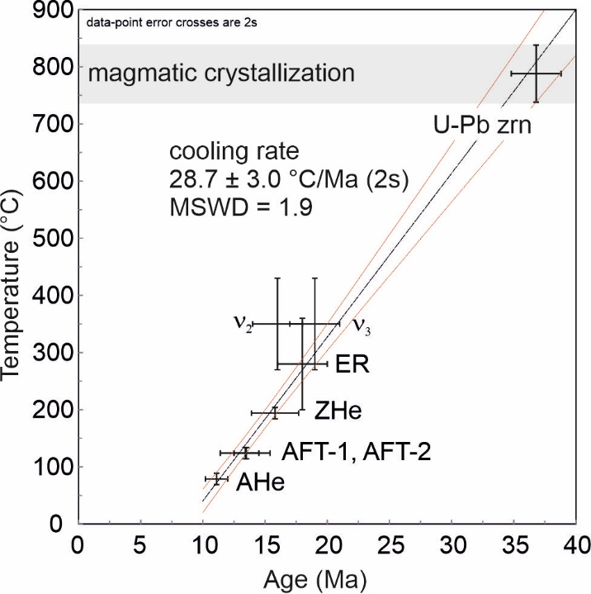
Figure S1. Temperature-time path for sample M71.

Text S2. Katha-range sample series K86 (5386), K91 (5391), and K92 (5392)

K86
Location: 24°14.317’ N, 96°11.420’ E, 157 m.
Petrology: Meta-acidic tectonite with aligned white mica and large modal amounts of quartz (some porphyritic). Other minerals are feldspar intergrown with white mica, zircon, apatite, sphene, opaques, tourmaline, and rare rutile. The protolith of the gneiss is interpreted as a hypabyssal granitoid or volcanic rock.
Geo-Thermochronology: Combined SHRIMP and LA-ICP-MS data yielded a U-Pb zircon crystallization age at 501.1 ± 8.6 Ma, with inheritance at 549.2 ± 4.8 Ma and 1118.1 ± 6.6 Ma (2s); LA-ICP-MS U-Pb rutile data define a range of chiefly discordant data with inheritance at 949 ± 12 Ma; the youngest dates define a lower intercept date of 35.8 ± 3.6 Ma (n = 8) with a non-Stacey–Kramers (Stacey and Kramers, 1975) ²⁰⁷Pb/²⁰⁶Pb intercept. ⁴⁰Ar/³⁹Ar white mica age is 39.3 ± 0.4 Ma (separate 1) and 38 ± 1 Ma (separate 2). Zircon (U-Th)/He (ZHe) age is 32.1 ± 4.2 Ma (n = 3).

K91
Location: 24°14.767’ N, 96°14.934’ E, 264 m
Petrology: Porphyroblastic chlorite-chloritoid-garnet micaschist (meta-pelite) tectonite (host rock of K86 and K92). Euhedral, poikiloblastic garnet has inclusions of quartz, chloritoid, chlorite, and ilmenite. Green chlorite is in a contact paragenesis with chloritoid. Phengite shows irregular zonation. Accessories are ilmenite, apatite, zircon, and rare rutile. Equilibrium assemblage calculations yielded peak-metamorphic P-T conditions of 497-511°C at 0.85-0.96 GPa, supported by conventional thermometry.
Geo-Thermochronology: Sample A, ⁴⁰Ar/³⁹Ar biotite age is 31.6 ± 5.6 Ma (2s). ZHe age is 28.5 ± 2.0 Ma (n = 2, 2s). AFT age is 13.9 ± 1.8 Ma. Sample B, LA-ICP-MS U-Pb rutile age with 8 spots is 453 ± 8 Ma (detrital inheritance). A Rb-Sr isochron, with 2 whole rock and 2 white mica separates, yielded 55.1 ± 3.5 Ma (2s). AFT age is 15.5 ± 10.0 Ma (2s).

K92
Location: 24°14.258’ N, 96°11.470’ E, 182 m
Petrology: Meta-acidic tectonite, interpreted as a hypabyssal granitoid or volcanic rock.
Geo-Thermochronology: LA-ICP-MS U-Pb zircon data indicate crystallization at 530 ± 11 Ma (2s), with inheritance at 714 ± 15, 1077 ± 20, and 1120 ± 22 Ma (2% uncertainty). Zircon fission-track (ZFT) age is 30.6 ± 3.8 Ma (2s).

Temperature-time (T-t) path (Katha-range path: samples K86, K91, K92): The magmatic crystallization temperatures for the Cambrian igneous crystallization were assumed at 700 ± 50 °C. The magmatic cooling was derived from the closure temperature difference between the U-Pb zircon and rutile systems; its low-temperature evolution is unconstrained. The peak of the Cenozoic reheating is constrained by the equilibrium assemblage calculations for sample K91. The Cenozoic cooling path was obtained as for sample M71. The closure temperatures and their uncertainties for the zircon Raman bands ν₂, ν₃, and ER are those of Härtel et al. (2021). We conclude that the Katha-range samples are Cambrian igneous and metasedimentary rocks that were reheated during Cenozoic burial and exhumed rapidly thereafter.

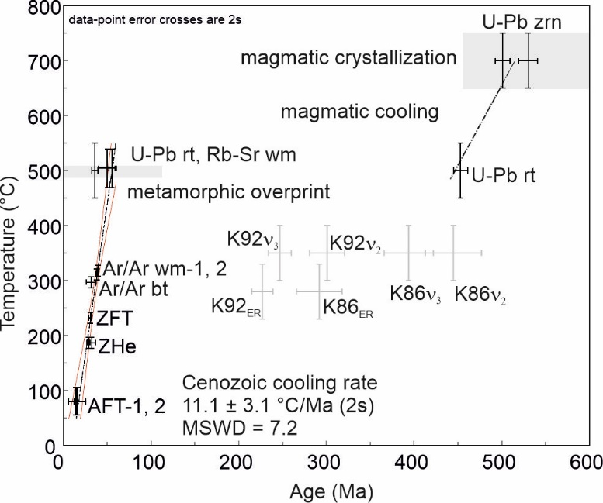
Figure S2. Temperature-time path for the Katha-range samples.

Text S3. Modeling radiation-damage accumulation and annealing in zircon
This appendix discusses forward modeling of damage accumulation and annealing for given thermal histories (T,t-paths), its uses and limitations. Following a Markov-chain approach (Guenthner, 2021), we divided an assumed T,t-path into a series of isothermal steps. The damage accumulated during each step is equal to the α-dose. The residual fraction left from annealing at each following step, r(t,T), is calculated from their duration (t) and absolute temperature (T) using a Johnson-Mehl-Avrami-Kolmogorov model (Härtel et al., 2021):
$r\left(t,T\right)=\text{exp}\left[−{\left(kt\right)}^{n}\right]$ (A.1),
${k=k}_{0}\text{exp}\left(\frac{−E_{A}}{κT}\right)$ (A.2).
E_{A} is the activation energy and n the Avrami exponent, k is the rate factor, k₀ the frequency factor, and κ the Boltzmann constant. The model parameters for the ν₂(SiO₄) and ER bands are derived from isothermal laboratory experiments (Härtel et al., 2021). For each time-step, we calculate the remaining portion of damage by multiplying the accumulated damage with r(t,T). We then calculate the annealing during the subsequent steps using the principle of equivalent time, which is equivalent to the Markov assumption and states that the damage fraction annealed during a step only depends on its previous degree of annealing and the prevailing time-temperature conditions. We calculate the total damage at each time-step by summing the damage fractions remaining at this step. Apart from the extrapolation of a laboratory experiment to geological timescales, this modeling approach rests on three assumptions: (1) the principle of equivalent time applies; (2) partially annealed and unannealed damage quantities can be summed; (3) the annealing rate is independent of the accumulated damage. We consider the results as provisional, but they provide a reasonable first-order estimate D₂ and D_{ER}.
Figures S3a and S3b show the thermal histories and the evolution of D₂/D_{ER} corresponding to the insets in Figure 5. Both thermal histories span 150 Myrs and describe a zircon with 3000 µg/g effective Uranium (eU = 1.04 [U] + 0.24 [Th]). The cooling path describes 100 Myrs cooling at 5 °C/Myr followed by 50 Myrs lossless damage accumulation. The reheating path describes damage accumulation for 80 Myrs, heating to 400 °C at 10 °C/Myr, and cooling to 20 °C at the same rate, before again accumulating damage for 15 Myrs. For the cooling path, D₂/D_{ER} peaks at a value of ~1.4 at about 300 °C in the middle of the cooling segment, and decreases afterwards, leading to a final value of ~1.1. For the reheating scenario, the D₂/D_{ER} reaches ~1.5 at the peak temperature, and decreases to a final value of ~1.3.
Figure S4 shows the D₂/D_{ER}-D_{ER} plot with trajectories for cooling at ~5 K/Myr and eU between 100 and 3000 µg/g. Because the relative annealing rates of D₂ and D_{ER} are independent of the accumulated damage, the ratio D₂/D_{ER} is the same for all paths in each time step, while eU determines the absolute value of D_{ER}. Our model implies that the D₂/D_{ER} is independent of eU; this implies that zircons from a population that experienced the same cooling path are distributed along a horizontal line in a D₂/D_{ER}-D_{ER} plot.
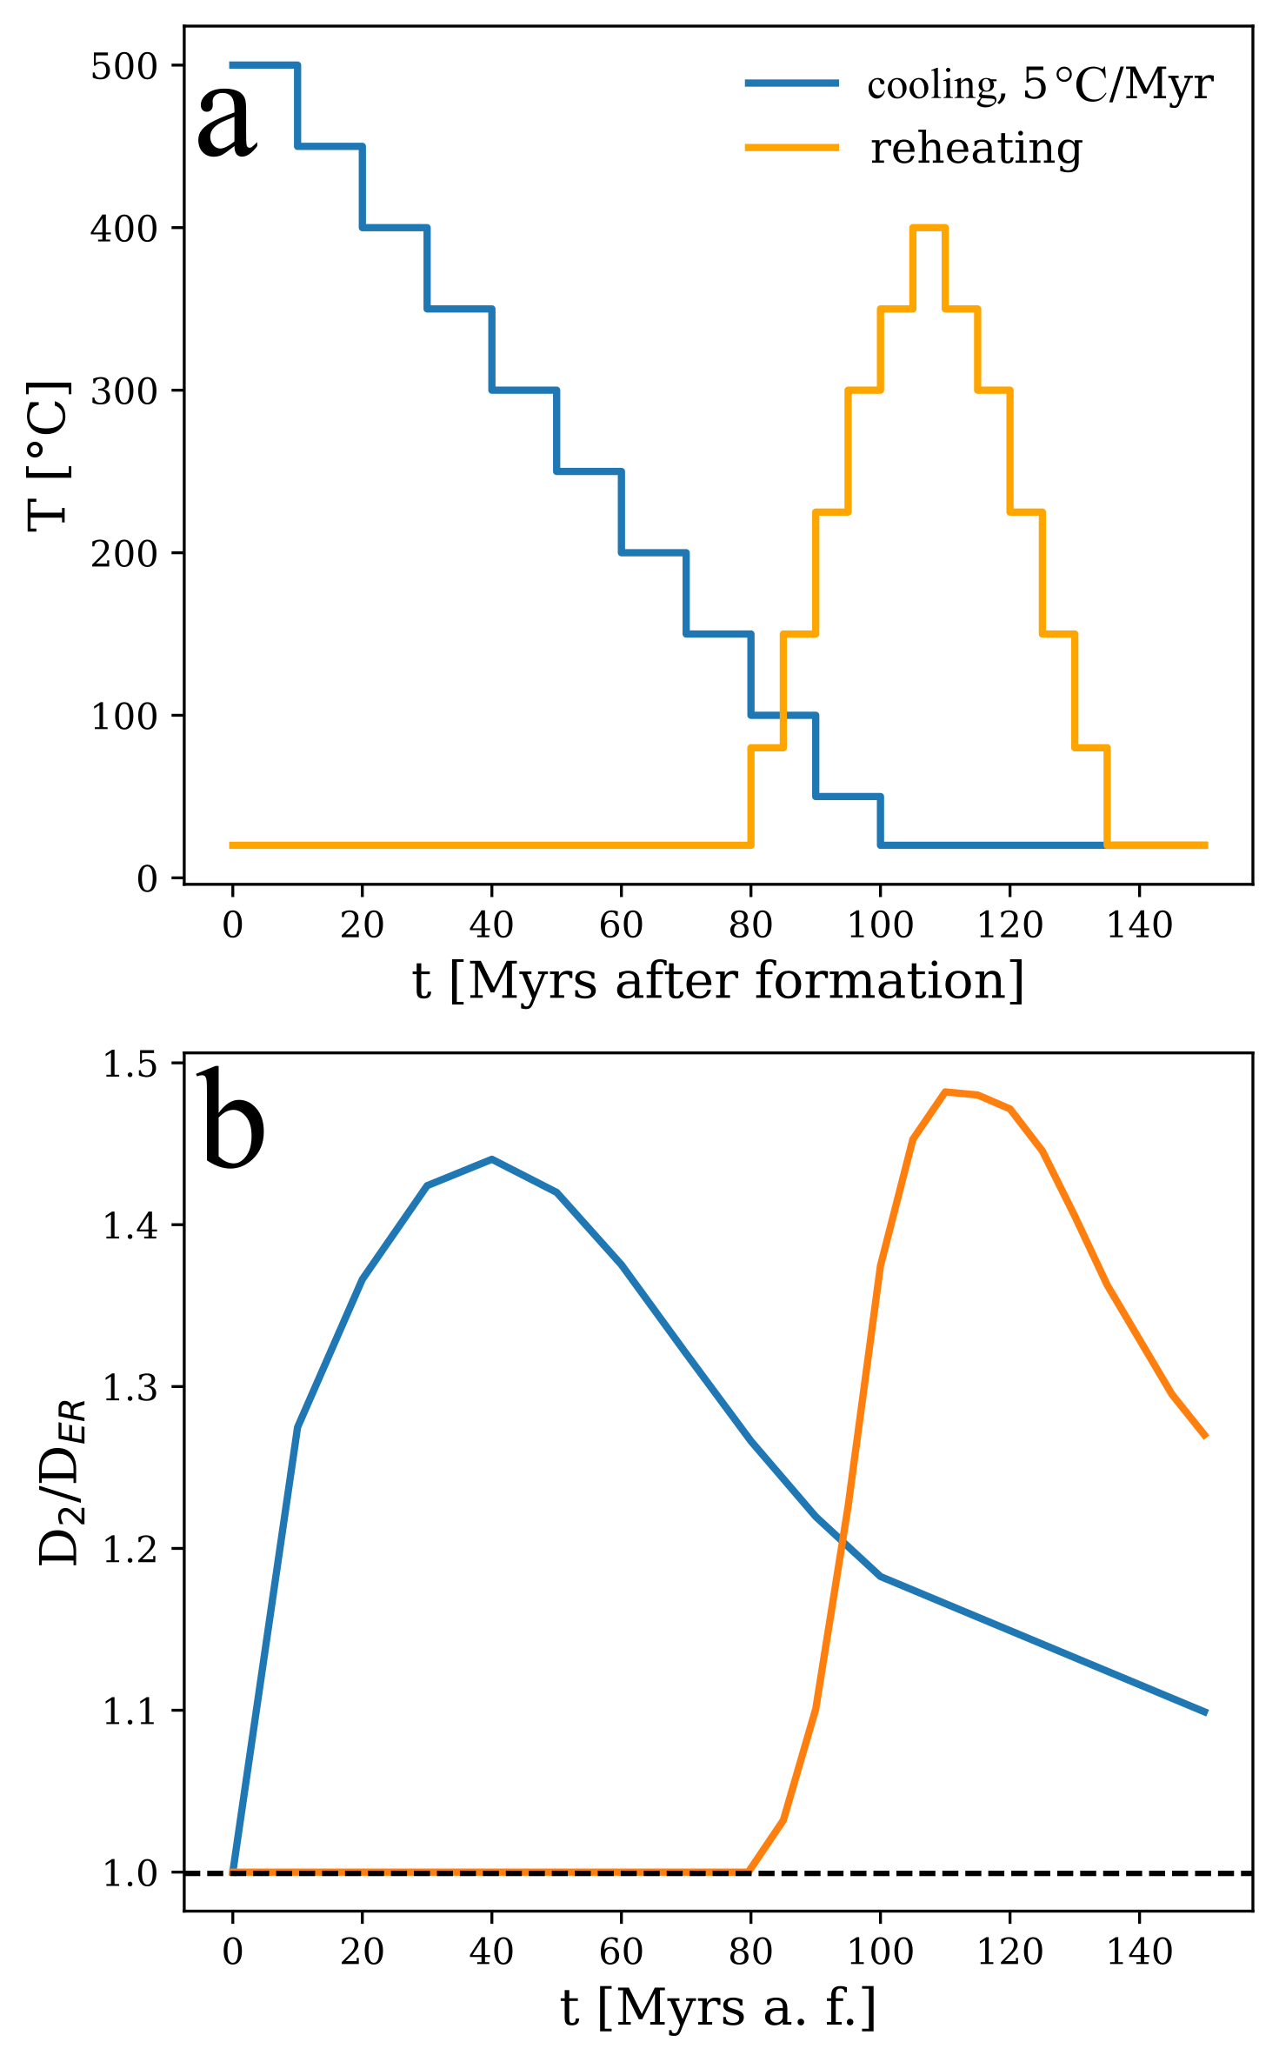
Figure S3. (a) T-t path and (b) temporal D₂/D_{ER} evolution for the modeled slow cooling and reheating lines in Figure 5. The accumulation and annealing paths were modeled for a zircon with eU = 3000 µg/g. The dashed black line in (b) marks the ratio of unannealed zircon.

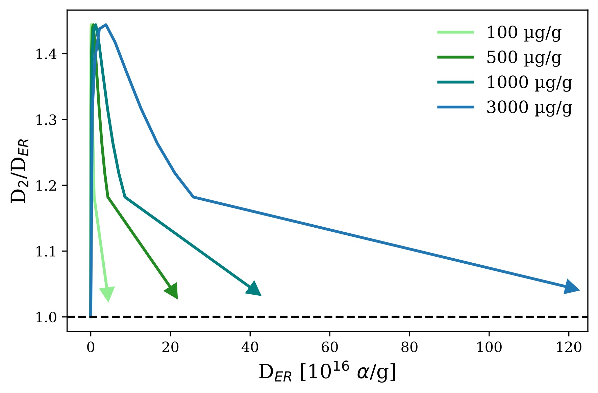
Figure S4. D₂/D_{ER}-D₂ plot for zircons with eU = 100, 500, 1000, and 3000 µg/g for a modeled cooling history at a cooling rate of 5 °C/Myr, followed by 50 Myr of damage accumulation. The dashed black line marks the ratio of unannealed zircon.
References
Brandon, M. T., Roden-Tice, M. K., & Garver, J. I. (1998), Late Cenozoic exhumation of the Cascadia accretionary wedge in the Olympic Mountains, northwest Washington State. GSA Bulletin 110, 985–1009.
Carlson, R. W. (2011), Absolute Age Determinations: Radiometric BT – Encyclopedia of Solid Earth Geophysics, in Gupta, H.K. ed., Springer Netherlands, Dordrecht, p. 1–8.
Guenthner, W.R (2021), Implementation of an Alpha Damage Annealing Model for Zircon (U-Th)/He Thermochronology With Comparison to a Zircon Fission Track Annealing Model. Geochemistry, Geophysics, Geosystems 22, e2019GC008757, doi:10.1029/2019GC008757.
Härtel, B., Jonckheere, R., Wauschkuhn, B., & Ratschbacher, L. (2021), The closure temperature(s) of zircon Raman dating. Geochronology 3, 259–272. https://doi.org/ 10.5194/gchron-3-259-2021.
Stacey, J. S., & Kramers, J. D. (1975), Approximation of terrestrial lead isotope evolution by a two-stage model. Earth Planetary Science Letters 26, 207–221.

